**Motion Detector**

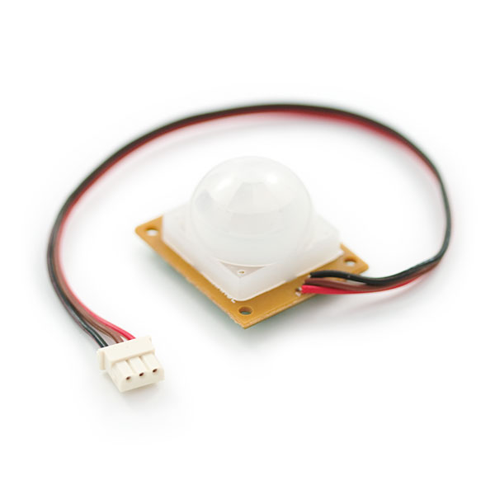

**What It Does**: The motion detect is similar to those in home security systems. It scans the area in view every few seconds, and determines if anything has moved.

**What It Tells You**:The motion detector can tell if you anything in view has moved. Once tripped it will rescan the area so if an object triggers the alarm, and then stays in place, it will not be triggered again. Additionally, extremely slow movement will not detected by the sensor.

**Required Connections**:The coloring on the pins of this device is different than others.

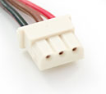

Connector on Motion Detector

Red Wire: This connection powers the detector, and should be connected to **5V**.  
Brown Wire: is the Ground connection and should be connected to **Ground/GND** on the Arduino.  
Black Wire: is the alarm. This should be connected to an **Analog Input**.

**Using the Motion Detector In Scratch**:

Use a *value of sensor* block to read in from the selected Analog Input. You will need on block for each axis. Adjust the pull down menu in the block to select the proper pin.

E:\My Dropbox\PhD\IDSA Workshop\Images\valueOfBlock.png

Read Data from Analog Input 0

Also, it will be helpful to store the reading into an appropriately named variable.

E:\My Dropbox\PhD\IDSA Workshop\Images\ReadInMotion.png

Read Sensor Measurement into a Variable

If the value of Motion is near 0, then the alarm has been tripped on the detector. In the example below, the value of motion is tested to see if it’s near zero. If so, that Arduino prints “Motion Detected” using the *say* block. Otherwise it prints that nothing is happening.

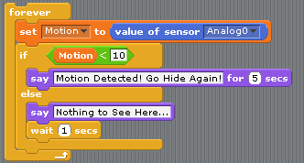

Motion Detector Example